|  |  |
| --- | --- |
| **EXERCISE NO:2**  **DATE:22/01/2025** | **COLOR MODELS** |

**AIM:**

To view the HSV image and CMY image of the color models and also of the extraction of the image in the different view and also the check saturation

and the empty matrix

**HOME PIC**

**ALGORITHM:**

1. Importing the library function of the open cv for image processing
2. Read the image using the imread function
3. Convert the image using function of the cvtColor in BGR to RGB
4. Execute the image
5. After the image is convert into the RGB color using the function cvt Color
6. Code of the RGB to the HSV and print the hue ,saturation and value separately to see the difference
7. Code of the RGB to the CMY and print the cryan ,magenta and value separately to see the difference
8. Check the difference of the pic
9. And the empty matrix and display the colour of the rgb and cmy

**CODE:**

import cv2

import matplotlib.pyplot as plt

import numpy as np

image = cv2.imread("Downloads/bilioniare.jpg")

image_rgb = cv2.cvtColor(image,cv2.COLOR_BGR2RGB)

plt.imshow(image_rgb)

plt.axis('off')

plt.title('Original image')

plt.show()

**OUTPUT:**

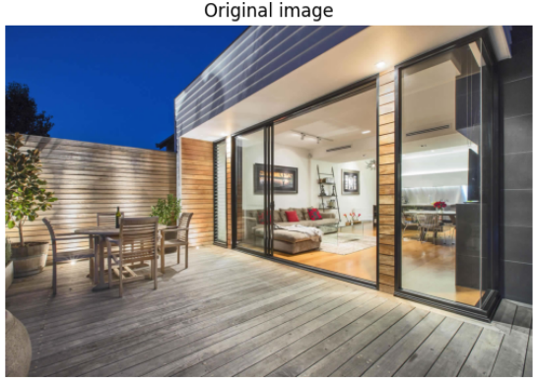

**CODE:**

rgb= image_rgb/255.0

cmy=1-rgb

cmy_image = (cmy*255).astype(np.uint8)

plt.imshow(cmy_image)

plt.axis('off')

plt.title('CMY Image')

plt.show()

**OUTPUT:**

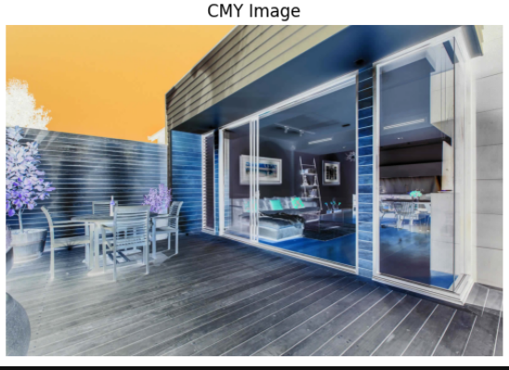

**CODE:**

hsv_image = cv2.cvtColor(image_rgb,cv2.COLOR_RGB2HSV)

plt.imshow(hsv_image)

plt.axis('off')

plt.title('HSV image ')

plt.show()

**OUTPUT:**

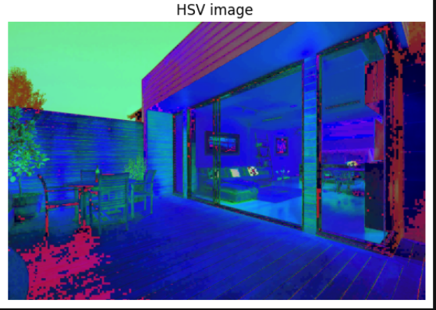

**SPLITING THE CHANNEL SEPARATELY FOR THE HSV AND CMY**

**CODE:**

import cv2

import numpy as np

import matplotlib.pyplot as plt

image_hsv = cv2.cvtColor(image, cv2.COLOR_BGR2HSV)

plt.figure(figsize=(12, 4))

hue = image_hsv[:, :, 0]

hue_colormap = cv2.applyColorMap(hue, cv2.COLORMAP_HSV)

plt.subplot(1, 3, 1)

plt.imshow(hue_colormap)

plt.title('Hue Channel')

plt.axis('off')

sat = image_hsv[:, :, 1]

sat_colormap = cv2.applyColorMap(sat, cv2.COLORMAP_JET)

# Plot the Saturation channel in the second subplot

plt.subplot(1, 3, 2) # 1 row, 3 columns, position 2

plt.imshow(sat_colormap)

plt.title('Saturation Channel')

plt.axis('off')

# ----- Value Channel -----

val = image_hsv[:, :, 2] # Extract the Value channel

# Scale Value to [0, 255] for better visualization

val_colormap = cv2.applyColorMap(val, cv2.COLORMAP_TURBO)

# Plot the Value channel in the third subplot

plt.subplot(1, 3, 3) # 1 row, 3 columns, position 3

plt.imshow(val_colormap)

plt.title('Value Channel')

plt.axis('off')

# Show the plots

plt.tight_layout() # Adjust the spacing between the subplots

plt.show()

**OUTPUT:**

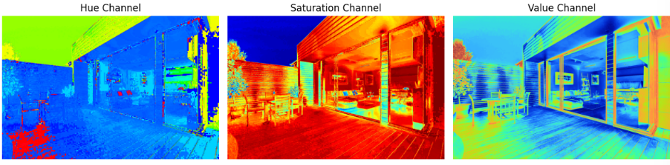

**CODE:**

image_rgb = cv2.cvtColor(image, cv2.COLOR_BGR2RGB)

plt.figure(figsize=(10, 5))

red = image_rgb.copy()

red[:, :, 1] = 0

red[:, :, 2] = 0

plt.subplot(1, 3, 1)

plt.imshow(red)

plt.title('Red Channel')

plt.axis('off')

green = image_rgb.copy()

green[:, :, 0] = 0

green[:, :, 2] = 0

plt.subplot(1, 3, 2)

plt.imshow(green)

plt.title('Green Channel')

plt.axis('off')

blue = image_rgb.copy()

blue[:, :, 0] = 0

blue[:, :, 1] = 0

plt.subplot(1, 3, 3)

plt.imshow(blue)

plt.title('Blue Channel')

plt.axis('off')

plt.tight_layout()

plt.show()

**OUTPUT:**

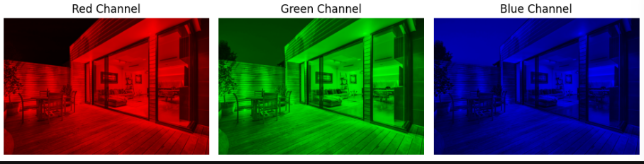

**CHECKING THE HSV AND CMY**

**CODE:**

import cv2

def modify_cmy (image,factor):

rgb= image/255.0

cmy=1-rgb

cmy_image = (cmy*255).astype(np.uint8)

R,G,B = cmy_image[:,:,0],cmy_image[:,:,1],cmy_image[:,:,2]

R =np.clip(R*factor ,0,255)

G = np.clip(G * factor, 0, 255)

B = np.clip(B * factor, 0, 255)

modified_cmy=np.stack([R,G,B],axis=-1).astype(np.uint8)

return modified_cmy

def modify_hsv(image,saturation_factor ):

hsv_image = cv2.cvtColor(image,cv2.COLOR_RGB2HSV).astype(np.float32)

H,S,V= hsv_image[:,:,0],hsv_image[:,:,1],hsv_image[:,:,2]

S=np.clip(S*saturation_factor,0,255)

hsv_image_modified =np.stack([H,S,V],axis=-1).astype(np.uint8)

return hsv_image_modified

modified_cmy_image= modify_cmy( image_rgb, factor=1.2)

modified_hsv_image= modify_hsv( image_rgb,saturation_factor=2)

plt.figure(figsize=(10,10))

plt.subplot(131)

plt.imshow(image_rgb)

plt.title("original image ")

plt.axis("off")

plt.subplot(132)

plt.imshow(modified_cmy_image)

plt.title("cmy ")

plt.axis("off")

plt.subplot(133)

plt.imshow(modified_hsv_image)

plt.title("hsv")

plt.axis("off")

**OUTPUT:**

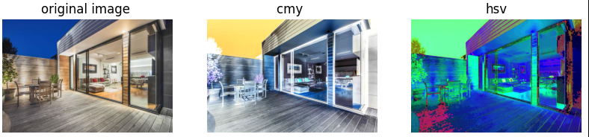

**CODE:**

import cv2

import numpy as np

import matplotlib.pyplot as plt

cmy1= modified_cmy_image

cmy1=cmy1/255.0

rgb2=1-cmy1

rgb=(rgb2*255).astype(np.uint8)

plt.figure(figsize=(100,100))

plt.subplot(131)

plt.imshow(rgb)

plt.title("cmy image ")

plt.axis("off")

**OUTPUT:**

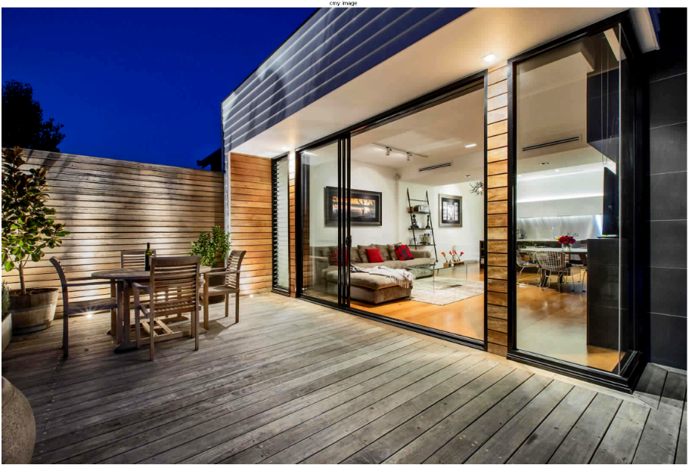

**CODE:**

import cv2

import numpy as np

import matplotlib.pyplot as plt

modified_rgb = cv2.cvtColor(modified_hsv_image, cv2.COLOR_HSV2RGB)

plt.figure(figsize=(100,100))

plt.subplot(131)

plt.imshow(modified_rgb)

plt.title("hsv to rgb image ")

plt.axis("off")

**OUTPUT:**

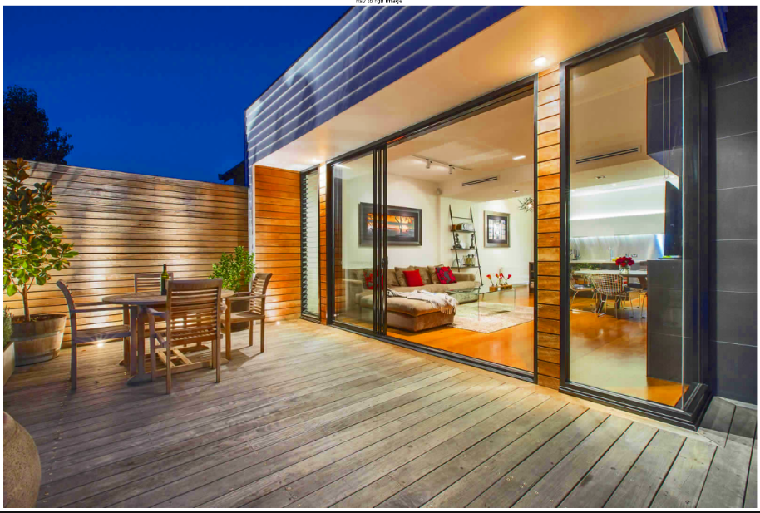

**REEMPTY MATRIX FOR CREATE COLOURS**

**CODE:**

import numpy as np

import matplotlib.pyplot as plt

# Create an empty matrix for an image

# Shape: (height, width, channels)

height, width = 300, 300 # Define image size

blank_image = np.zeros((height, width, 3), dtype=np.uint8) # RGB image initialized to black

# Create colors

# Fill Red channel

red_image = blank_image.copy()

red_image[:, :, 0] = 255 # Set the Red channel to maximum (255)

# Fill Green channel

green_image = blank_image.copy()

green_image[:, :, 1] = 255 # Set the Green channel to maximum (255)

# Fill Blue channel

blue_image = blank_image.copy()

blue_image[:, :, 2] = 255 # Set the Blue channel to maximum (255)

# Combine Red + Green to create Yellow

yellow_image = blank_image.copy()

yellow_image[:, :, 0] = 255 # Red

yellow_image[:, :, 1] = 255 # Green

# Combine Green + Blue to create Cyan

cyan_image = blank_image.copy()

cyan_image[:, :, 1] = 255 # Green

cyan_image[:, :, 2] = 255 # Blue

# Combine Red + Blue to create Magenta

magenta_image = blank_image.copy()

magenta_image[:, :, 0] = 255 # Red

magenta_image[:, :, 2] = 255 # Blue

# Display the results

plt.figure(figsize=(12, 8))

plt.subplot(231)

plt.imshow(red_image)

plt.title("Red")

plt.axis("off")

plt.subplot(232)

plt.imshow(green_image)

plt.title("Green")

plt.axis("off")

plt.subplot(233)

plt.imshow(blue_image)

plt.title("Blue")

plt.axis("off")

plt.subplot(234)

plt.imshow(yellow_image)

plt.title("Yellow (Red + Green)")

plt.axis("off")

plt.subplot(235)

plt.imshow(cyan_image)

plt.title("Cyan (Green + Blue)")

plt.axis("off")

plt.subplot(236)

plt.imshow(magenta_image)

plt.title("Magenta (Red + Blue)")

plt.axis("off")

plt.tight_layout()

plt.show()

**OUTPUT:**

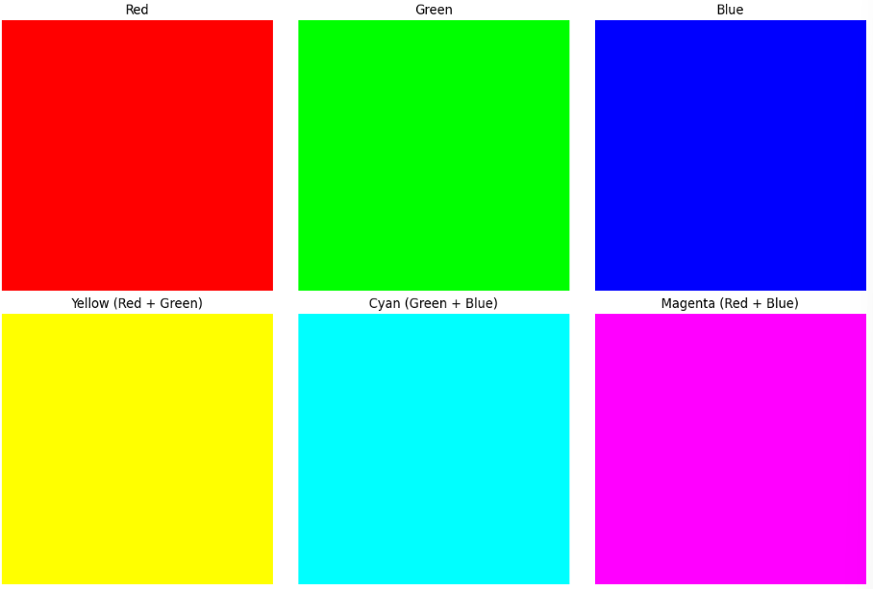

**FREEFIRE PIC**

**ALGORITHM:**

1. Importing the library function of the open cv for image processing
2. Read the image using the imread function
3. Convert the image using function of the cvtColor in BGR to RGB
4. Execute the image
5. After the image is convert into the RGB color using the function cvt Color
6. Code of the RGB to the HSV and print the hue ,saturation and value separately to see the difference
7. Code of the RGB to the CMY and print the cryan ,magenta and value separately to see the difference
8. Check the difference of the pic
9. And the empty matrix and display the colour of the rgb and cmy

**CODE:**

import cv2

import matplotlib.pyplot as plt

import numpy as np

image = cv2.imread("Downloads/ garena-free-fire-4k-v8.jpg")

image_rgb = cv2.cvtColor(image,cv2.COLOR_BGR2RGB)

plt.imshow(image_rgb)

plt.axis('off')

plt.title('Original image')

plt.show()

**OUTPUT:**

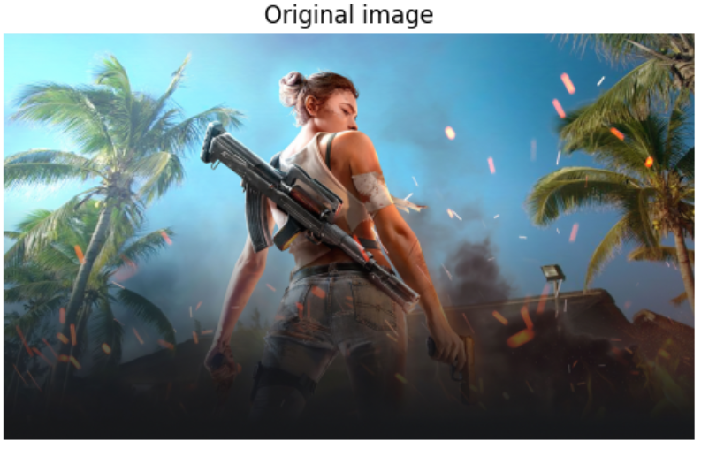

**CODE:**

rgb= image_rgb/255.0

cmy=1-rgb

cmy_image = (cmy*255).astype(np.uint8)

plt.imshow(cmy_image)

plt.axis('off')

plt.title('CMY Image')

plt.show()

**OUTPUT:**

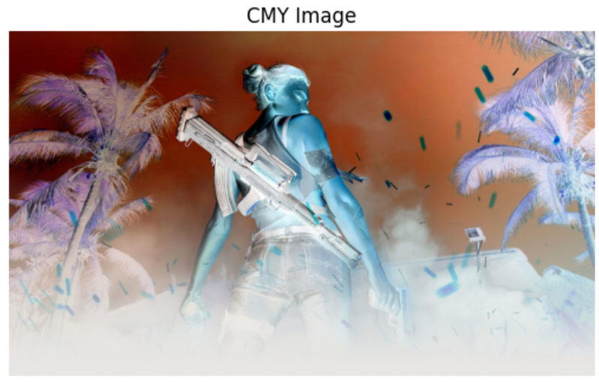

**CODE:**

hsv_image = cv2.cvtColor(image_rgb,cv2.COLOR_RGB2HSV)

plt.imshow(hsv_image)

plt.axis('off')

plt.title('HSV image ')

plt.show()

**OUTPUT:**

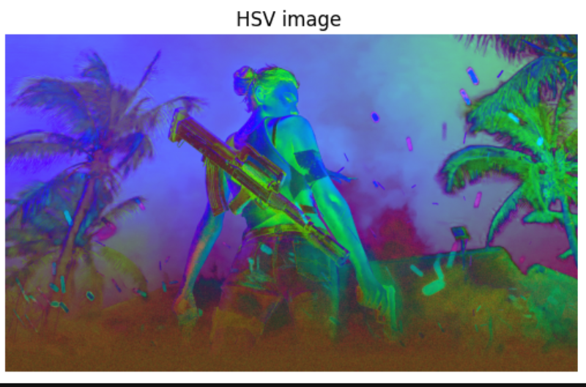

**SPLITING THE CHANNEL SEPARATELY FOR THE HSV AND CMY**

**CODE:**

import cv2

import numpy as np

import matplotlib.pyplot as plt

image_hsv = cv2.cvtColor(image, cv2.COLOR_BGR2HSV)

plt.figure(figsize=(12, 4))

hue = image_hsv[:, :, 0]

hue_colormap = cv2.applyColorMap(hue, cv2.COLORMAP_HSV)

plt.subplot(1, 3, 1)

plt.imshow(hue_colormap)

plt.title('Hue Channel')

plt.axis('off')

sat = image_hsv[:, :, 1]

sat_colormap = cv2.applyColorMap(sat, cv2.COLORMAP_JET)

# Plot the Saturation channel in the second subplot

plt.subplot(1, 3, 2) # 1 row, 3 columns, position 2

plt.imshow(sat_colormap)

plt.title('Saturation Channel')

plt.axis('off')

# ----- Value Channel -----

val = image_hsv[:, :, 2] # Extract the Value channel

# Scale Value to [0, 255] for better visualization

val_colormap = cv2.applyColorMap(val, cv2.COLORMAP_TURBO)

# Plot the Value channel in the third subplot

plt.subplot(1, 3, 3) # 1 row, 3 columns, position 3

plt.imshow(val_colormap)

plt.title('Value Channel')

plt.axis('off')

# Show the plots

plt.tight_layout() # Adjust the spacing between the subplots

plt.show()

**OUTPUT:**

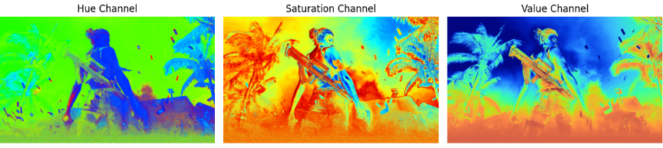

**CODE:**

image_rgb = cv2.cvtColor(image, cv2.COLOR_BGR2RGB)

plt.figure(figsize=(10, 5))

red = image_rgb.copy()

red[:, :, 1] = 0

red[:, :, 2] = 0

plt.subplot(1, 3, 1)

plt.imshow(red)

plt.title('Red Channel')

plt.axis('off')

green = image_rgb.copy()

green[:, :, 0] = 0

green[:, :, 2] = 0

plt.subplot(1, 3, 2)

plt.imshow(green)

plt.title('Green Channel')

plt.axis('off')

blue = image_rgb.copy()

blue[:, :, 0] = 0

blue[:, :, 1] = 0

plt.subplot(1, 3, 3)

plt.imshow(blue)

plt.title('Blue Channel')

plt.axis('off')

plt.tight_layout()

plt.show()

**OUTPUT:**



**CHECKING THE HSV AND CMY**

**CODE:**

import cv2

def modify_cmy (image,factor):

rgb= image/255.0

cmy=1-rgb

cmy_image = (cmy*255).astype(np.uint8)

R,G,B = cmy_image[:,:,0],cmy_image[:,:,1],cmy_image[:,:,2]

R =np.clip(R*factor ,0,255)

G = np.clip(G * factor, 0, 255)

B = np.clip(B * factor, 0, 255)

modified_cmy=np.stack([R,G,B],axis=-1).astype(np.uint8)

return modified_cmy

def modify_hsv(image,saturation_factor ):

hsv_image = cv2.cvtColor(image,cv2.COLOR_RGB2HSV).astype(np.float32)

H,S,V= hsv_image[:,:,0],hsv_image[:,:,1],hsv_image[:,:,2]

S=np.clip(S*saturation_factor,0,255)

hsv_image_modified =np.stack([H,S,V],axis=-1).astype(np.uint8)

return hsv_image_modified

modified_cmy_image= modify_cmy( image_rgb, factor=1.2)

modified_hsv_image= modify_hsv( image_rgb,saturation_factor=2)

plt.figure(figsize=(10,10))

plt.subplot(131)

plt.imshow(image_rgb)

plt.title("original image ")

plt.axis("off")

plt.subplot(132)

plt.imshow(modified_cmy_image)

plt.title("cmy ")

plt.axis("off")

plt.subplot(133)

plt.imshow(modified_hsv_image)

plt.title("hsv")

plt.axis("off")

**OUTPUT:**

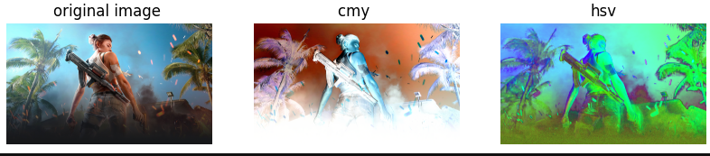

**CODE:**

import cv2

import numpy as np

import matplotlib.pyplot as plt

cmy1= modified_cmy_image

cmy1=cmy1/255.0

rgb2=1-cmy1

rgb=(rgb2*255).astype(np.uint8)

plt.figure(figsize=(100,100))

plt.subplot(131)

plt.imshow(rgb)

plt.title("cmy image ")

plt.axis("off")

**OUTPUT:**

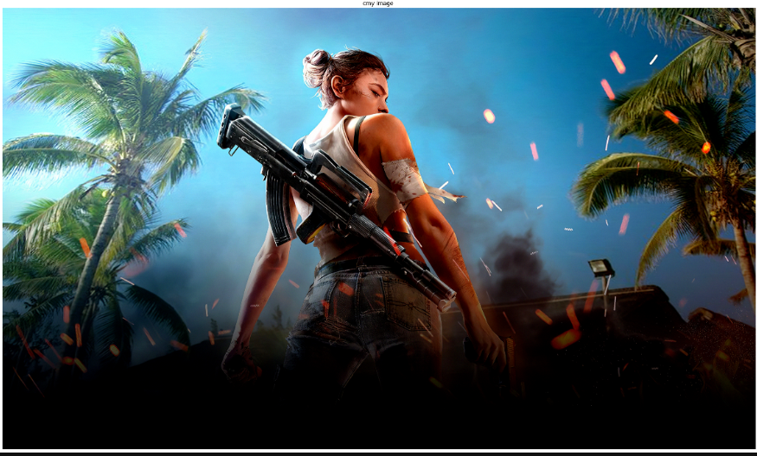

**CODE:**

import cv2

import numpy as np

import matplotlib.pyplot as plt

modified_rgb = cv2.cvtColor(modified_hsv_image, cv2.COLOR_HSV2RGB)

plt.figure(figsize=(100,100))

plt.subplot(131)

plt.imshow(modified_rgb)

plt.title("hsv to rgb image ")

plt.axis("off")

**OUTPUT:** 

**REEMPTY MATRIX FOR CREATE COLOURS**

**CODE:**

import numpy as np

import matplotlib.pyplot as plt

# Create an empty matrix for an image

# Shape: (height, width, channels)

height, width = 300, 300 # Define image size

blank_image = np.zeros((height, width, 3), dtype=np.uint8) # RGB image initialized to black

# Create colors

# Fill Red channel

red_image = blank_image.copy()

red_image[:, :, 0] = 255 # Set the Red channel to maximum (255)

# Fill Green channel

green_image = blank_image.copy()

green_image[:, :, 1] = 255 # Set the Green channel to maximum (255)

# Fill Blue channel

blue_image = blank_image.copy()

blue_image[:, :, 2] = 255 # Set the Blue channel to maximum (255)

# Combine Red + Green to create Yellow

yellow_image = blank_image.copy()

yellow_image[:, :, 0] = 255 # Red

yellow_image[:, :, 1] = 255 # Green

# Combine Green + Blue to create Cyan

cyan_image = blank_image.copy()

cyan_image[:, :, 1] = 255 # Green

cyan_image[:, :, 2] = 255 # Blue

# Combine Red + Blue to create Magenta

magenta_image = blank_image.copy()

magenta_image[:, :, 0] = 255 # Red

magenta_image[:, :, 2] = 255 # Blue

# Display the results

plt.figure(figsize=(12, 8))

plt.subplot(231)

plt.imshow(red_image)

plt.title("Red")

plt.axis("off")

plt.subplot(232)

plt.imshow(green_image)

plt.title("Green")

plt.axis("off")

plt.subplot(233)

plt.imshow(blue_image)

plt.title("Blue")

plt.axis("off")

plt.subplot(234)

plt.imshow(yellow_image)

plt.title("Yellow (Red + Green)")

plt.axis("off")

plt.subplot(235)

plt.imshow(cyan_image)

plt.title("Cyan (Green + Blue)")

plt.axis("off")

plt.subplot(236)

plt.imshow(magenta_image)

plt.title("Magenta (Red + Blue)")

plt.axis("off")

plt.tight_layout()

plt.show()

**OUTPUT:**



**RESULT:**

We have successfully executed basic of the color and using emprty to create colour image